Bridge between Denmark and Sweden
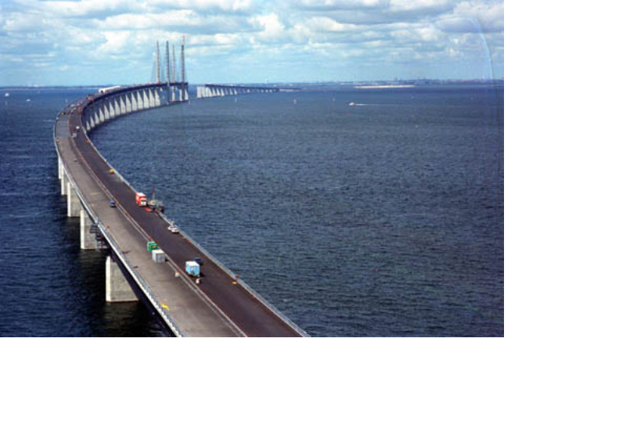
On July 1, 2000, the combined tunnel and bridge connecting Denmark and Sweden was officially opened. It consists of a tunnel from Copenhagen to an artificial island, and a bridge from the island to Malmö in Sweden. The major construction materials employed are concrete and steel. This problem deals with chemical reactions relating to production and degradation of such materials.

Concrete is produced from a mixture of cement, water, sand and small stones. Cement consists primarily of calcium silicates and calcium aluminates formed by heating and grinding of clay and limestone. In the later steps of cement production a small amount of gypsum, CaSO₄∙2H₂O, is added to improve subsequent hardening of the concrete. The use of elevated temperatures during the final production may lead to formation of unwanted hemihydrate, CaSO₄∙½H₂O. Consider the following reaction:

CaSO₄∙2H₂O(s) → CaSO₄∙½H₂O(s) + 1½H₂O(g)

The following thermodynamic data apply at 25 °C, standard pressure: 1.00 bar:
Compound | H/(kJ mol^{–1}) (ΔH_{f}) | S/(J K^{–1} mol^{–1})
CaSO₄∙2H₂O(s) | –2021.0 | 194.0
CaSO₄∙½H₂O(s) | –1575.0 | 130.5
H₂O(g) | –241.8 | 188.6

Gas constant: R = 8.314 J mol^{–1} K^{–1} = 0.08314 L bar mol^{–1} K^{–1}
0 °C = 273.15 K.

- Calculate ΔH (in kJ) for transformation of 1.00 kg of CaSO₄∙2H₂O(s) to CaSO₄∙½H₂O(s). Is this reaction endothermic or is it exothermic?

Mark with an X.: Endothermic Exothermic

- Calculate the equilibrium pressure (in bar) of water vapour in a closed vessel containing CaSO₄∙2H₂O(s), CaSO₄∙½H₂O(s) and H₂O(g) at 25 °C.

- Calculate the temperature at which the equilibrium water vapour pressure is 1.00 bar in the system described in problem 2-2. Assume that ΔH and ΔS are temperature independent.

Corrosion of metals is associated with electrochemical reactions. This also applies for the formation of rust on iron surfaces, where the initial electrode reactions usually are:
(1) Fe(s) → Fe²⁺(aq) + 2e–

(2) O₂(g) + 2H₂O(l) + 4e– → 4OH–(aq)

An electrochemical cell in which these electrode reactions take place is constructed. The temperature is 25 ºC. The cell is represented by the following cell diagram:
Fe(s) ⏐ Fe²⁺(aq) ⏐⏐ OH–(aq), O₂(g) ⏐ Pt(s)
Standard electrode potentials (at 25 ºC):
Fe²⁺(aq) + 2e– → Fe(s) E = – 0.44 V
O₂(g) + 2H₂O(l) + 4e– → 4OH–(aq) E = 0.40 V
Nernst factor: R T ln10 / F = 0.05916 volt (at 25 ºC)
Faraday constant: F = 96485 C mol^{–1}

- Calculate the standard electromotive force (the standard cell voltage), E,
at 25 ºC.

- Write down the overall reaction which takes place during discharge of the cell under standard conditions.

- Calculate the equilibrium constant at 25 °C for the overall cell reaction.

- The overall reaction referred to above is allowed to proceed for 24 hours under standard conditions and at a constant current of 0.12 A. Calculate the mass of Fe converted to Fe²⁺ after 24 hours. Oxygen and water may be assumed to be present in excess.

- Calculate E for the cell at 25 °C for the following conditions:
[Fe²⁺] = 0.015 m, pH_{right-hand half-cell} = 9.00, p(O₂) = 0.700 bar.

